Premium Wan Reference Video Prompts 25 to 30
Six bride and dress replacement templates for 15 second Wan 3 0 Prime generation
This document brings together the six prepared Premium Wan templates numbered 25 through 30. Each template includes its reference thumbnail, links to the prepared video and original music, source and Supabase storage details, and the complete production prompt. All six references are 15 seconds long and are prepared for owner review before registration or generation.

Generation input roles
- VIDEO 1 controls performance, body language, shot order, timing, camera, setting and light. It does not control the replacement bride, outfit or jewellery.
- The first uploaded image supplies the bride's facial identity. The following dress views supply one exact garment and its matching dupatta.
- The jewellery placeholder is replaced at runtime with database jewellery instructions or the minimal jewellery fallback.
- A face-only bride image does not guarantee a lean or fuller body build. Exact body-build replacement needs a full-body bride reference or an approved full-body still in the generation pipeline.
- The MP4 files are linked rather than embedded, so they open from this project workspace. Supabase entries are private object paths and require normal application access or a signed URL.

Template summary
No | Template | Format | Source
25 | Garden Bridal Reverie | 9:16 vertical | Daacn5tI87C
26 | Red Lit Mirror Bride | 16:9 landscape | DX_7s2sTa16
27 | Ivory Garden Veil | 9:16 vertical | DbDYe6GyUfF
28 | Crimson Tapestry Letter | 9:16 vertical | DVWKa-JkdVG
29 | Crimson Veil Courtyard | 9:16 vertical | DbI6I1UJ-q6
30 | Veiled Corridor Reverie | 16:9 landscape | Dac-pRtMZs_

Template 25 Garden Bridal Reverie
15 seconds 9:16 vertical 9 shots 4,414 prompt characters
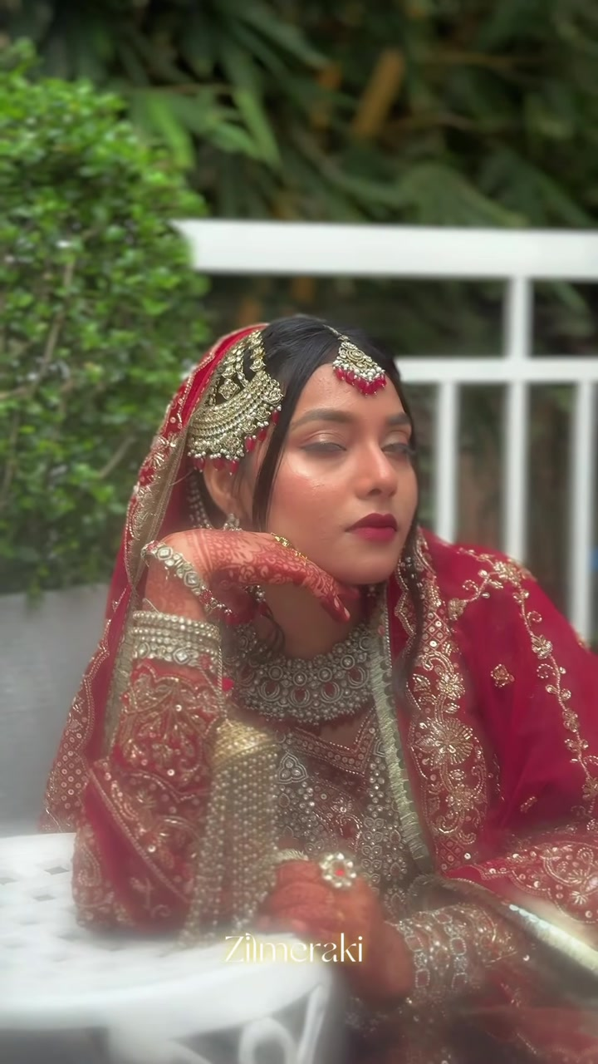
Prepared reference thumbnail
Open prepared reference video Open original music Open source reel

Reference details
Source shortcode Daacn5tI87C
Source window 0.00 to 15.00 seconds
Prepared reference 15.00 seconds with no audio stream
Supabase bucket ladies-planet private
Original source object premium-wan/intake/Daacn5tI87C/source-original.mp4
Prepared reference object premium-wan/templates/premium-wan-25/reference-15s.mp4
Jewellery placeholder Present exactly 1 time

Complete Wan prompt
PROJECT: LADIES PLANET — GARDEN BRIDAL REVERIE
MODEL: WAN 3.0 PRIME | 15 SECONDS | 9:16 VERTICAL | SILENT

OBJECTIVE
Recreate VIDEO 1 shot for shot with a different bride. Replace only three things: the woman's identity, her complete outfit and her jewellery. Everything else in VIDEO 1 stays the same. This is subject-and-wardrobe replacement, not a new concept and not an unchanged copy of VIDEO 1.

REFERENCE ROLES
VIDEO 1 = motion, expressions, gaze, hand and finger positions, poses, camera angle and movement, framing, shot order, cuts, timing, slow motion, environment and lighting. Never use its woman's face, outfit, dupatta or jewellery.
FIRST image = the BRIDE. Facial identity only.
FOLLOWING images = the DRESS. All views show ONE garment and its matching dupatta.
Jewellery reference: see section 5.

1. FACE IDENTITY
The bride is the woman in the BRIDE image in every frame, not a similar woman. Preserve face shape and proportions, eyes and spacing, eyebrows, nose, lips, cheeks, jaw, chin, forehead, hairline, skin tone, natural asymmetry and skin texture. Never blend or alternate with VIDEO 1's woman. The face follows every head turn, tilt and light change; no pasted or floating face, no seams, no beauty filter. Ignore the BRIDE image's clothing and accessories.

2. MOTION AND SHOT TIMELINE
0.0–1.5s: High close detail over a garden hedge; both hennaed hands hover and glide gently above the leaves while embroidered sleeves and bangles enter from frame right; shallow focus, soft handheld drift, blur cut.
1.5–2.8s: Waist-up side portrait beside the hedge and white railing; the bride turns her face toward camera with a restrained smile while her hands remain extended; soft haze, steady framing.
2.8–5.4s: Seated medium close-up beside an ornate white chair; she holds both hennaed palms upright near her face, studies them with a lowered gaze, then looks ahead; minimal camera drift, blur transition.
5.4–6.9s: Frontal seated close-up; eyes closed, chin poised between the backs of both raised hands, elbows supported; calm stillness and dreamy foreground haze.
6.9–9.3s: Same close-up; she slowly turns her face toward screen right, opens her eyes and settles her gaze toward camera; gentle focus breathing and a soft blur at the cut.
9.3–11.0s: Three-quarter standing portrait near the railing; body angled toward screen right, one hand gathers the dupatta at her waist as her head turns toward camera; stable slow-motion frame.
11.0–12.1s: Seated close portrait; both hands rise near her ear and cheek, gaze lifts toward screen right, then steadies; soft foreground haze.
12.1–13.5s: Dreamy blurred side-profile transition as the veiled bride shifts position beside the railing; keep the source's defocus and warm flare.
13.5–15.0s: Full-length side portrait on the veranda; she stands facing screen right with hands composed at her waist, then turns her eyes toward camera while the frame holds.
Match VIDEO 1's speed and cut points exactly. No extra shots, poses, gestures or camera moves.

3. EXACT DRESS AND DUPATTA
The DRESS images are the only authority for the outfit: colour, silhouette, neckline, sleeves, bodice, fabric, embroidery motifs and placement, borders and construction. The matching dupatta from the DRESS images is mandatory; VIDEO 1 decides only how it moves and is held. Never reuse VIDEO 1's outfit or dupatta. Unseen areas stay plain and consistent, not invented.

4. NO MANNEQUIN
Take only the garment from the DRESS images. Ignore any mannequin, stand, hanger or display bust. Zero mannequin parts or white plastic patches on the bride; natural human body, skin and proportions.

5. JEWELLERY
{{JEWELLERY_BLOCK}}

6. ENVIRONMENT
Outdoor garden veranda with white railings, columns and an ornate white metal chair against dense green foliage. Keep the warm daylight, soft diffusion, shallow depth of field, foreground haze and original framing. Do not reproduce the source watermark or introduce text, logos, new people, props or effects.

7. CONTINUITY
Same face, dress, dupatta and jewellery in every frame. Realistic hands with five fingers, natural fabric weight and folds. No flicker, morphing embroidery, colour shifts, floating jewellery, distorted limbs, watermark or captions.

PRIORITIES: 1) VIDEO 1 shot sequence and motion. 2) Bride face identity. 3) Exact dress and dupatta. 4) No mannequin. 5) Jewellery rule. 6) Natural anatomy and continuity.

Template 26 Red Lit Mirror Bride
15 seconds 16:9 landscape 9 shots 4,449 prompt characters
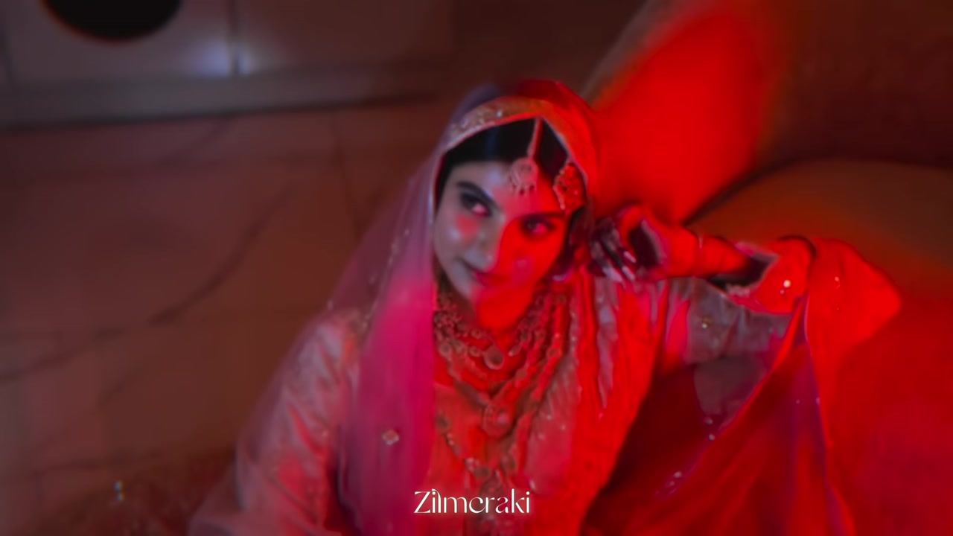
Prepared reference thumbnail
Open prepared reference video Open original music Open source reel

Reference details
Source shortcode DX_7s2sTa16
Source window 0.00 to 15.00 seconds
Prepared reference 15.00 seconds with no audio stream
Supabase bucket ladies-planet private
Original source object premium-wan/intake/DX_7s2sTa16/source-original.mp4
Prepared reference object premium-wan/templates/premium-wan-26/reference-15s.mp4
Jewellery placeholder Present exactly 1 time

Complete Wan prompt
PROJECT: LADIES PLANET — RED-LIT MIRROR BRIDE
MODEL: WAN 3.0 PRIME | 15 SECONDS | 16:9 LANDSCAPE | SILENT

OBJECTIVE
Recreate VIDEO 1 shot for shot with a different bride. Replace only three things: the woman's identity, her complete outfit and her jewellery. Everything else in VIDEO 1 stays the same. This is subject-and-wardrobe replacement, not a new concept and not an unchanged copy of VIDEO 1.

REFERENCE ROLES
VIDEO 1 = motion, expressions, gaze, hand and finger positions, poses, camera angle and movement, framing, shot order, cuts, timing, slow motion, environment and lighting. Never use its woman's face, outfit, dupatta or jewellery.
FIRST image = the BRIDE. Facial identity only.
FOLLOWING images = the DRESS. All views show ONE garment and its matching dupatta.
Jewellery reference: see section 5.

1. FACE IDENTITY
The bride is the woman in the BRIDE image in every frame, not a similar woman. Preserve face shape and proportions, eyes and spacing, eyebrows, nose, lips, cheeks, jaw, chin, forehead, hairline, skin tone, natural asymmetry and skin texture. Never blend or alternate with VIDEO 1's woman. The face follows every head turn, tilt and light change; no pasted or floating face, no seams, no beauty filter. Ignore the BRIDE image's clothing and accessories.

2. MOTION AND SHOT TIMELINE
0.0–1.0s: Overhead close detail of crossed hennaed hands and wrists resting on the spread skirt; saturated red light with moving circular colour flares, gentle focus drift, hard cut.
1.0–2.8s: High-angle seated medium portrait; the bride holds the dupatta edge in both hands, gaze lowered toward it, then begins lifting her eyes; slow dreamy motion with red/orange halos.
2.8–4.2s: Front high-angle medium shot; she raises her right hand beside her ear and meets camera with a composed expression; shallow focus pulses softly.
4.2–6.4s: Slightly wider seated portrait against a cushioned chair; right hand stays near her ear, head tips back and eyes look upward; camera drifts minimally through saturated red light.
6.4–7.5s: Return to the high-angle pose; she holds the dupatta edge and lowers her gaze back toward camera as a flare passes; hard cut.
7.5–8.8s: Bright neutral-room close crop from chest to forehead; her hennaed right palm is upright beside her face while she looks down and off-camera; soft haze and slight focus drift.
8.8–10.4s: Mirror-room composition; three-quarter profile appears beyond a large white sculptural vase and pale pampas, with her reflection behind; she looks toward the mirror during a gentle lateral reveal.
10.4–12.5s: Frontal close portrait behind out-of-focus pale flowers; she faces camera with a calm gaze as the camera holds and the foreground haze drifts.
12.5–15.0s: Extreme soft-focus bridal detail in warm neutral light; hands and embroidered fabric move slowly behind translucent foreground blur, preserving the abstract framing until the end.
Match VIDEO 1's speed and cut points exactly. No extra shots, poses, gestures or camera moves.

3. EXACT DRESS AND DUPATTA
The DRESS images are the only authority for the outfit: colour, silhouette, neckline, sleeves, bodice, fabric, embroidery motifs and placement, borders and construction. The matching dupatta from the DRESS images is mandatory; VIDEO 1 decides only how it moves and is held. Never reuse VIDEO 1's outfit or dupatta. Unseen areas stay plain and consistent, not invented.

4. NO MANNEQUIN
Take only the garment from the DRESS images. Ignore any mannequin, stand, hanger or display bust. Zero mannequin parts or white plastic patches on the bride; natural human body, skin and proportions.

5. JEWELLERY
{{JEWELLERY_BLOCK}}

6. ENVIRONMENT
Preserve the first red-lit interior with cushioned seating, deep shadows and circular coloured flares, then the hard cut to the bright neutral dressing room with mirror, white sculptural vase and pale pampas. Keep the shallow depth of field, haze, colour grade and framing. Do not reproduce the source watermark or introduce text, logos, people, props or effects.

7. CONTINUITY
Same face, dress, dupatta and jewellery in every frame. Realistic hands with five fingers, natural fabric weight and folds. No flicker, morphing embroidery, colour shifts, floating jewellery, distorted limbs, watermark or captions.

PRIORITIES: 1) VIDEO 1 shot sequence and motion. 2) Bride face identity. 3) Exact dress and dupatta. 4) No mannequin. 5) Jewellery rule. 6) Natural anatomy and continuity.

Template 27 Ivory Garden Veil
15 seconds 9:16 vertical 12 shots 4,444 prompt characters
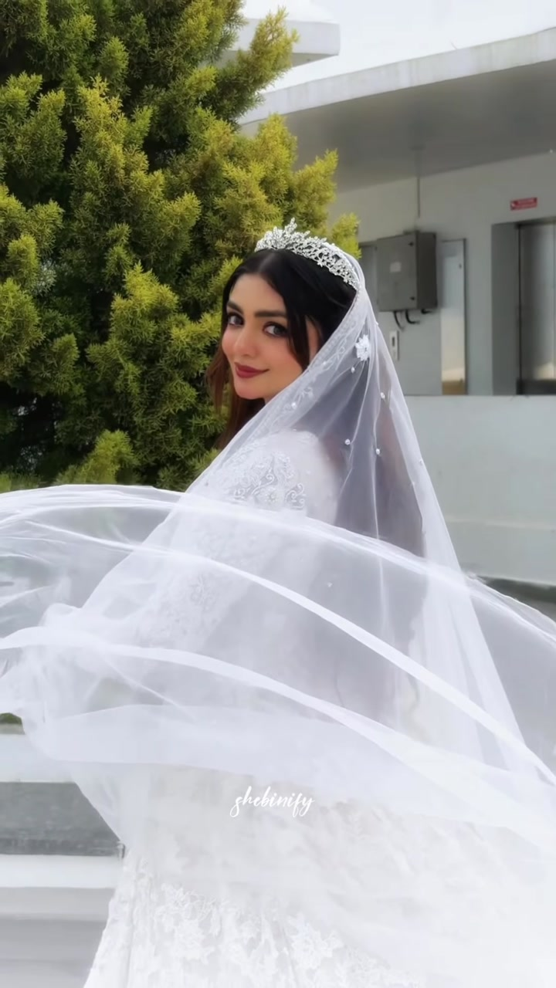
Prepared reference thumbnail
Open prepared reference video Open original music Open source reel

Reference details
Source shortcode DbDYe6GyUfF
Source window 0.00 to 15.00 seconds
Prepared reference 15.00 seconds with no audio stream
Supabase bucket ladies-planet private
Original source object premium-wan/intake/DbDYe6GyUfF/source-original.mp4
Prepared reference object premium-wan/templates/premium-wan-27/reference-15s.mp4
Jewellery placeholder Present exactly 1 time

Complete Wan prompt
PROJECT: LADIES PLANET — IVORY GARDEN VEIL
MODEL: WAN 3.0 PRIME | 15 SECONDS | 9:16 VERTICAL | SILENT

OBJECTIVE
Recreate VIDEO 1 shot for shot with a different bride. Replace only the woman's identity, complete outfit and jewellery. Everything else stays the same. This is replacement, not a new concept or unchanged copy of VIDEO 1.

REFERENCE ROLES
VIDEO 1 = motion, expressions, gaze, hand and finger positions, poses, camera angle and movement, framing, shot order, cuts, timing, slow motion, environment and lighting. Never use its woman's face, outfit, dupatta or jewellery.
FIRST image = the BRIDE. Facial identity only.
FOLLOWING images = the DRESS. All views show ONE garment and its matching dupatta.
Jewellery reference: see section 5.

1. FACE IDENTITY
The bride is the woman in the BRIDE image in every frame, not a similar woman. Preserve face shape and proportions, eyes and spacing, eyebrows, nose, lips, cheeks, jaw, chin, forehead, hairline, skin tone, natural asymmetry and skin texture. Never blend or alternate with VIDEO 1's woman. The face follows every head turn, tilt and light change; no pasted or floating face, no seams, no beauty filter. Ignore the BRIDE image's clothing and accessories.

2. MOTION AND SHOT TIMELINE
0.0–1.3s: Waist-up garden side portrait; one hand rests along her cheek and neck as her eyes turn toward camera, then hold a faint smile; gentle push, hard cut.
1.3–2.4s: High-angle beauty close-up; both hands frame her chin and cheek, gaze lowered then drifting sideways; soft white flare and shallow focus.
2.4–3.6s: Seated medium portrait on the terrace; hands settle over her lap, chin lifts and eyes meet camera during a slight push-in.
3.6–4.3s: Closer seated three-quarter portrait; forearms remain composed across her lap and she holds a calm direct gaze.
4.3–5.6s: Standing medium portrait against green trees; she makes a small poised hand gesture near her chest while facing camera.
5.6–6.8s: Distant full-length view beyond foreground grass; arms extend slightly outward beside the wide skirt as the camera pushes closer through a brief blur.
6.8–8.5s: Medium-full moving portrait; she glides forward with arms relaxed outward, looks down briefly, then returns her gaze toward camera.
8.5–11.4s: The matching dupatta sweeps across the lens in translucent waves, revealing an over-shoulder three-quarter pose; she looks back at camera with a restrained smile while it billows.
11.4–12.5s: Close-up against pale sky; one hand touches her throat and jaw, head angled slightly toward screen right, gaze held off-camera.
12.5–13.2s: Tighter frontal close-up; one hand rises beside her ear and hair as her eyes meet camera.
13.2–14.1s: Three-quarter standing portrait among palms and trees; shoulders angled, face toward camera, then a quick blur transition.
14.1–15.0s: Full-length garden portrait; she looks down at the skirt, lightly holds its sides and gives the fabric a gentle outward sway.
Match VIDEO 1's speed and cut points exactly. No extra shots, poses, gestures or camera moves.

3. EXACT DRESS AND DUPATTA
The DRESS images are the only authority for the outfit: colour, silhouette, neckline, sleeves, bodice, fabric, embroidery motifs and placement, borders and construction. The matching dupatta from the DRESS images is mandatory; VIDEO 1 decides only how it moves and is held. Never reuse VIDEO 1's outfit or dupatta. Unseen areas stay plain and consistent, not invented.

4. NO MANNEQUIN
Take only the garment from the DRESS images. Ignore any mannequin, stand, hanger or display bust. Zero mannequin parts or white plastic patches on the bride; natural human body, skin and proportions.

5. JEWELLERY
{{JEWELLERY_BLOCK}}

6. ENVIRONMENT
Modern white garden terrace with low walls and benches, manicured grass, palms and dense green trees under soft overcast daylight. Keep the source's bright neutral grade, shallow focus, foreground grass and fabric wipes. Do not reproduce the source watermark or introduce text, logos, new people, props or effects.

7. CONTINUITY
Same face, dress, dupatta and jewellery in every frame. Realistic hands with five fingers, natural fabric weight and folds. No flicker, morphing embroidery, colour shifts, floating jewellery, distorted limbs, watermark or captions.

PRIORITIES: 1) VIDEO 1 shot sequence and motion. 2) Bride face identity. 3) Exact dress and dupatta. 4) No mannequin. 5) Jewellery rule. 6) Natural anatomy and continuity.

Template 28 Crimson Tapestry Letter
15 seconds 9:16 vertical 10 shots 4,292 prompt characters
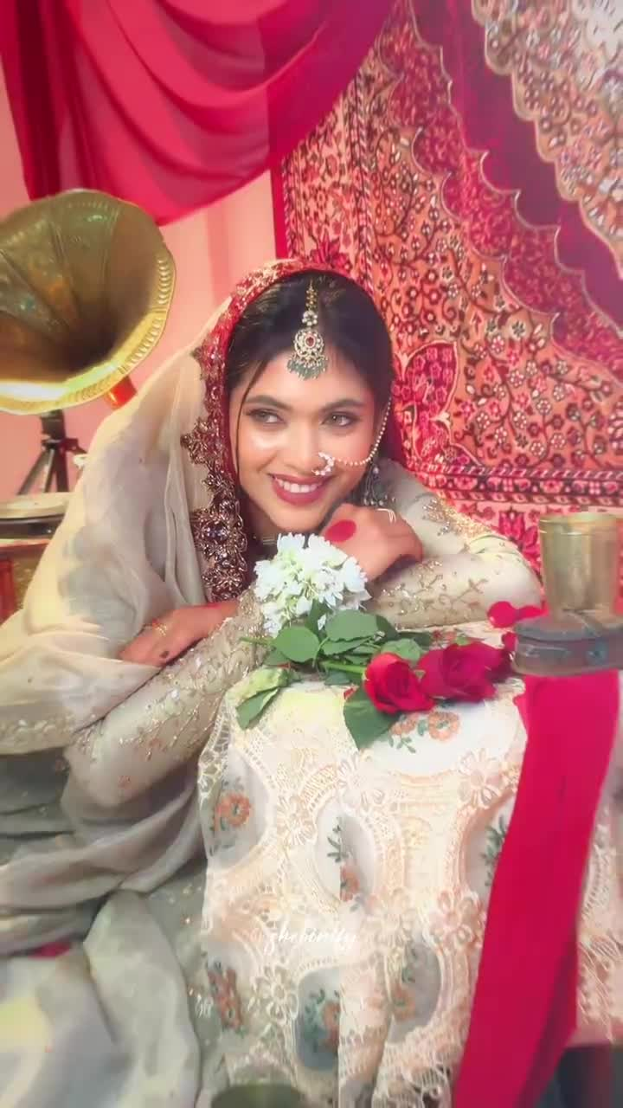
Prepared reference thumbnail
Open prepared reference video Open original music Open source reel

Reference details
Source shortcode DVWKa-JkdVG
Source window 0.00 to 15.00 seconds
Prepared reference 15.00 seconds with no audio stream
Supabase bucket ladies-planet private
Original source object premium-wan/intake/DVWKa-JkdVG/source-original.mp4
Prepared reference object premium-wan/templates/premium-wan-28/reference-15s.mp4
Jewellery placeholder Present exactly 1 time

Complete Wan prompt
PROJECT: LADIES PLANET — CRIMSON TAPESTRY LETTER
MODEL: WAN 3.0 PRIME | 15 SECONDS | 9:16 VERTICAL | SILENT

OBJECTIVE
Recreate VIDEO 1 shot for shot with a different bride. Replace only the woman's identity, complete outfit and jewellery. Everything else stays the same. This is replacement, not a new concept or unchanged copy of VIDEO 1.

REFERENCE ROLES
VIDEO 1 = motion, expressions, gaze, hand and finger positions, poses, camera angle and movement, framing, shot order, cuts, timing, slow motion, environment and lighting. Never use its woman's face, outfit, dupatta or jewellery.
FIRST image = the BRIDE. Facial identity only.
FOLLOWING images = the DRESS. All views show ONE garment and its matching dupatta.
Jewellery reference: see section 5.

1. FACE IDENTITY
The bride is the woman in the BRIDE image in every frame, not a similar woman. Preserve face shape and proportions, eyes and spacing, eyebrows, nose, lips, cheeks, jaw, chin, forehead, hairline, skin tone, natural asymmetry and skin texture. Never blend or alternate with VIDEO 1's woman. The face follows every head turn, tilt and light change; no pasted or floating face, seams or beauty filter. Ignore the BRIDE image's clothing and accessories.

2. MOTION AND SHOT TIMELINE
0.0–1.2s: Tight high-angle portrait; seated bride leans forward with forearms crossed, looks down and smiles broadly as the camera drifts slightly; hard cut.
1.2–4.0s: Medium portrait beside the lace-covered table and red-and-white bouquet; chin rests near crossed arms, eyes glance toward screen right and the smile holds; gentle push-in.
4.0–5.1s: Seated medium close-up; she cups a small lit candle in both palms, looks down at its flame and smiles; subtle handheld movement.
5.1–6.9s: Wider three-quarter seated view; she lifts and turns the red rose bouquet lightly between both hands while looking at it; skirt spreads across the floor.
6.9–8.0s: Close three-quarter portrait; cheek rests on one hand, elbow by the table, eyes lift off-camera and she smiles; brief push.
8.0–10.4s: Frontal medium portrait; she sits upright with forearms folded over one raised knee, looks directly at camera and holds a warm smile; soft flare at the opening, then steady framing.
10.4–11.3s: Overhead hand-and-lap insert; both hands hold an unfolded handwritten letter above the skirt while the camera hovers close.
11.3–13.6s: Medium close portrait; she reads the letter, eyes tracking down the page, then her lips form a restrained smile; slight push-in.
13.6–14.5s: Tight coy portrait; she raises the matching dupatta around both cheeks, lowers her gaze and smiles; quick clean cut.
14.5–15.0s: Close hand detail; both hands cradle the red rose bouquet over the skirt, one rose petal resting on the back of her hand.
Match VIDEO 1's speed and cut points exactly. No extra shots, poses, gestures or camera moves.

3. EXACT DRESS AND DUPATTA
The DRESS images are the only authority for the outfit: colour, silhouette, neckline, sleeves, bodice, fabric, embroidery motifs and placement, borders and construction. The matching dupatta from the DRESS images is mandatory; VIDEO 1 decides only how it moves and is held. Never reuse VIDEO 1's outfit or dupatta. Unseen areas stay plain and consistent, not invented.

4. NO MANNEQUIN
Take only the garment from the DRESS images. Ignore any mannequin, stand, hanger or display bust. Zero mannequin parts or white plastic patches on the bride; natural human body, skin and proportions.

5. JEWELLERY
{{JEWELLERY_BLOCK}}

6. ENVIRONMENT
Intimate vintage bridal salon with crimson drapery, a richly patterned red tapestry, red floor seating, brass gramophone and hookah, and a small floral lace-covered table. Keep the warm saturated light, shallow focus, red roses, candle and handwritten letter. Do not reproduce the source watermark or introduce text, logos, new people, props or effects.

7. CONTINUITY
Same face, dress, dupatta and jewellery in every frame. Realistic hands with five fingers, natural fabric weight and folds. No flicker, morphing embroidery, colour shifts, floating jewellery, distorted limbs, watermark or captions.

PRIORITIES: 1) VIDEO 1 shot sequence and motion. 2) Bride face identity. 3) Exact dress and dupatta. 4) No mannequin. 5) Jewellery rule. 6) Natural anatomy and continuity.

Template 29 Crimson Veil Courtyard
15 seconds 9:16 vertical 8 shots 4,274 prompt characters
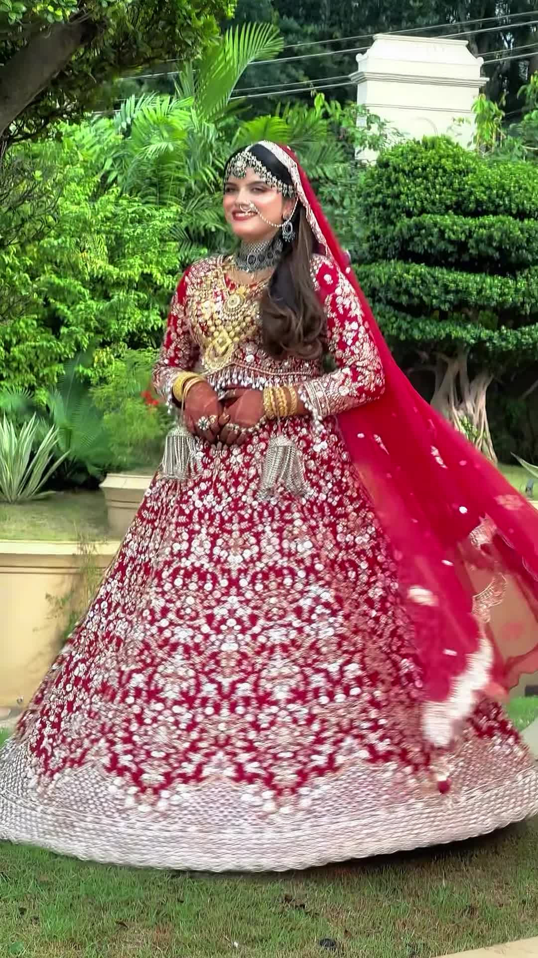
Prepared reference thumbnail
Open prepared reference video Open original music Open source reel

Reference details
Source shortcode DbI6I1UJ-q6
Source window 0.00 to 15.00 seconds
Prepared reference 15.00 seconds with no audio stream
Supabase bucket ladies-planet private
Original source object premium-wan/intake/DbI6I1UJ-q6/source-archive.mp4
Prepared reference object premium-wan/templates/premium-wan-29/reference-15s.mp4
Jewellery placeholder Present exactly 1 time

Complete Wan prompt
PROJECT: LADIES PLANET — CRIMSON VEIL COURTYARD
MODEL: WAN 3.0 PRIME | 15 SECONDS | 9:16 VERTICAL | SILENT

OBJECTIVE
Recreate VIDEO 1 shot for shot with a different bride. Replace only the woman's identity, complete outfit and jewellery. Everything else stays the same. This is replacement, not a new concept or unchanged copy of VIDEO 1.

REFERENCE ROLES
VIDEO 1 = motion, expressions, gaze, hand and finger positions, poses, camera angle and movement, framing, shot order, cuts, timing, slow motion, environment and lighting. Never use its woman's face, outfit, dupatta or jewellery.
FIRST image = the BRIDE. Facial identity only.
FOLLOWING images = the DRESS. All views show ONE garment and its matching dupatta.
Jewellery reference: see section 5.

1. FACE IDENTITY
The bride is the woman in the BRIDE image in every frame, not a similar woman. Preserve face shape and proportions, eyes and spacing, eyebrows, nose, lips, cheeks, jaw, chin, forehead, hairline, skin tone, natural asymmetry and skin texture. Never blend or alternate with VIDEO 1's woman. The face follows every head turn, tilt and light change; no pasted or floating face, seams or beauty filter. Ignore the BRIDE image's clothing and accessories.

2. MOTION AND SHOT TIMELINE
0.0–1.7s: Frontal medium portrait beneath the pale portico; the matching dupatta covers her face as a translucent veil, body still and gaze faintly visible; restrained push-in and bright flare into the cut.
1.7–3.9s: Low-angle medium close portrait against horizontal stone louvers; she holds the dupatta edge across her chest with both hands, reveals her face and smiles directly toward camera.
3.9–6.1s: Garden-side medium portrait; body angled toward screen right, one hand rises holding a tiny white flower, chin lifts and her eyes follow it with a warm smile; slight lateral drift.
6.1–7.7s: Tighter garden portrait; both hands touch the dupatta edges beside her temples, gently settling it over her hair as her expression becomes composed and her gaze meets camera.
7.7–10.9s: Full-length architectural portrait beside the louvered wall and terrace; she stands poised with hands low near the skirt, makes a small weight shift and smiles while the camera eases wider.
10.9–13.0s: Full-length lawn portrait; she completes one smooth turn as the skirt follows with weight and the matching dupatta streams outward, then faces camera while the fabric settles.
13.0–14.3s: Tight three-quarter portrait beside the carved wooden doorway; cheek rests on one hand, eyes glance sideways and a reserved smile forms during a gentle push.
14.3–15.0s: Garden medium close portrait; shoulders turn slightly toward screen right while one hand gathers her hair near the shoulder and she holds a soft sideward smile.
Match VIDEO 1's speed and cut points exactly. No extra shots, poses, gestures or camera moves.

3. EXACT DRESS AND DUPATTA
The DRESS images are the only authority for the outfit: colour, silhouette, neckline, sleeves, bodice, fabric, embroidery motifs and placement, borders and construction. The matching dupatta from the DRESS images is mandatory; VIDEO 1 decides only how it moves and is held. Never reuse VIDEO 1's outfit or dupatta. Unseen areas stay plain and consistent, not invented.

4. NO MANNEQUIN
Take only the garment from the DRESS images. Ignore any mannequin, stand, hanger or display bust. Zero mannequin parts or white plastic patches on the bride; natural human body, skin and proportions.

5. JEWELLERY
{{JEWELLERY_BLOCK}}

6. ENVIRONMENT
Elegant tropical residence courtyard with pale stone porticos, horizontal louvered walls, carved wooden doors, tiled terrace, lawn and dense manicured greenery under bright overcast daylight. Keep the source's natural colour, soft flare, depth of field and framing. Do not reproduce its watermark or add text, logos, people, props or effects.

7. CONTINUITY
Same face, dress, dupatta and jewellery in every frame. Realistic hands with five fingers, natural fabric weight and folds. No flicker, morphing embroidery, colour shifts, floating jewellery, distorted limbs, watermark or captions.

PRIORITIES: 1) VIDEO 1 shot sequence and motion. 2) Bride face identity. 3) Exact dress and dupatta. 4) No mannequin. 5) Jewellery rule. 6) Natural anatomy and continuity.

Template 30 Veiled Corridor Reverie
15 seconds 16:9 landscape 8 shots 4,211 prompt characters
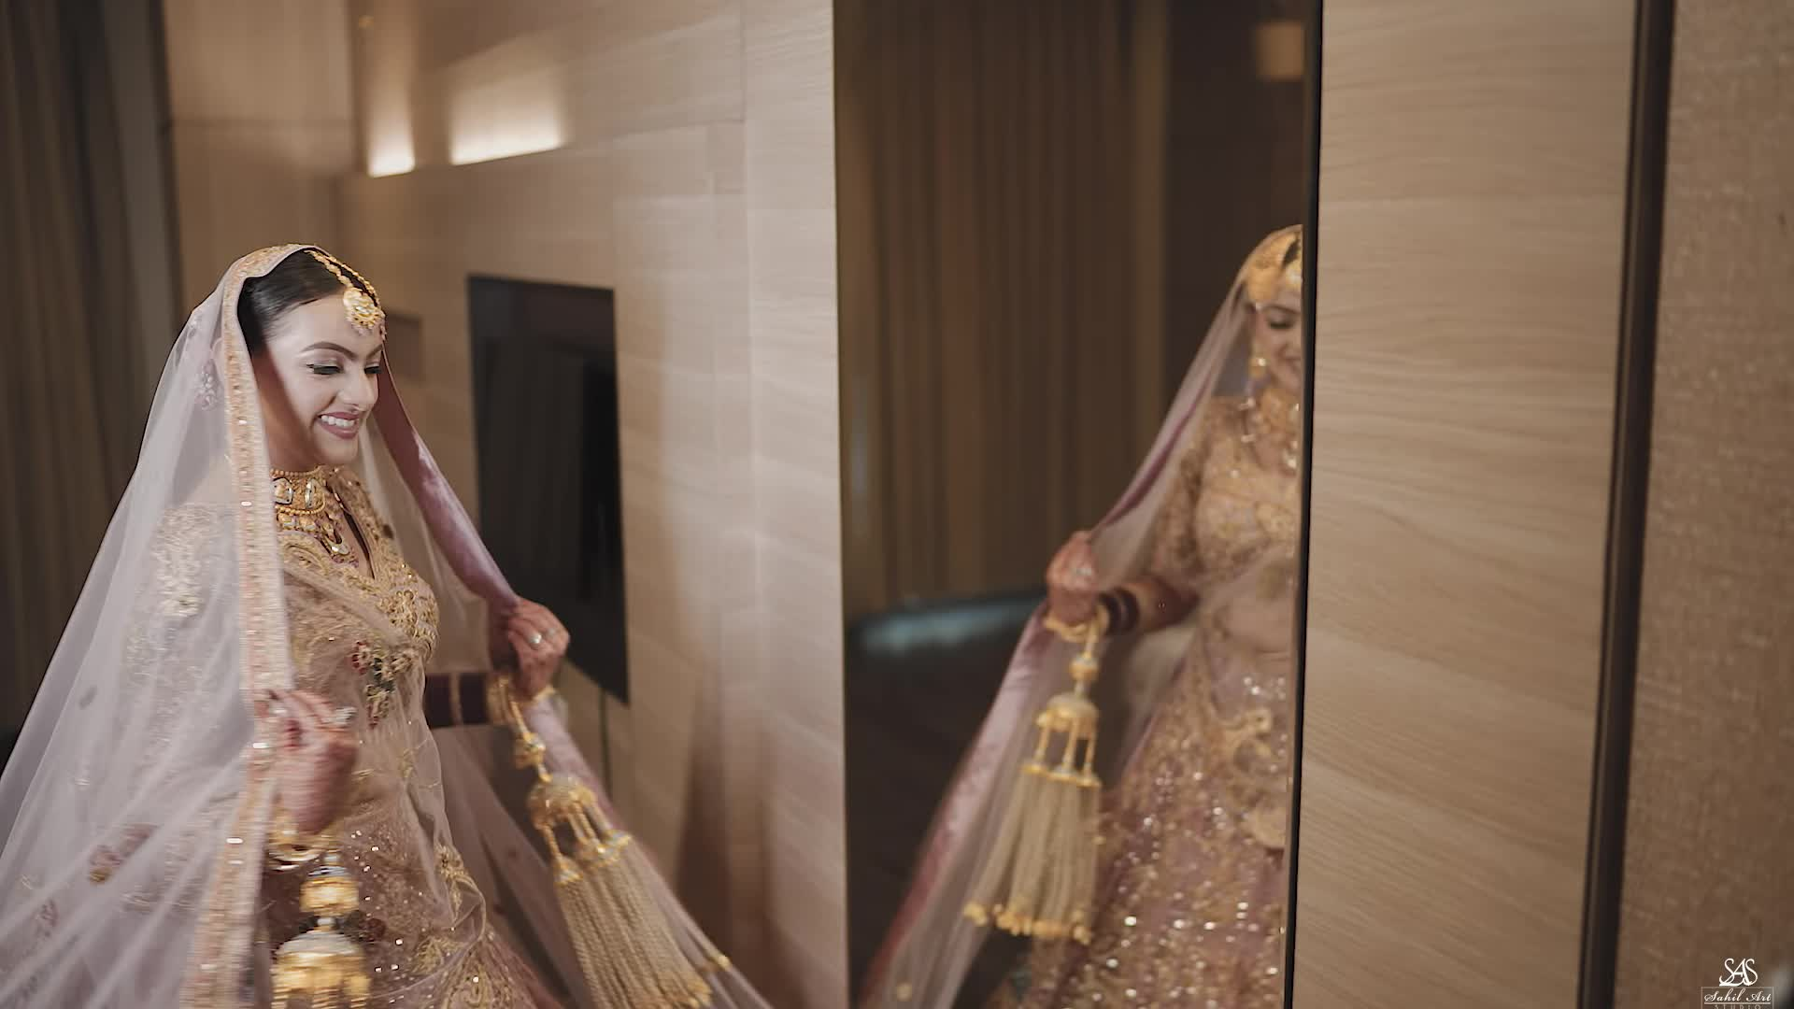
Prepared reference thumbnail
Open prepared reference video Open original music Open source reel

Reference details
Source shortcode Dac-pRtMZs_
Source window 6.50 to 21.50 seconds
Prepared reference 15.00 seconds with no audio stream
Supabase bucket ladies-planet private
Original source object premium-wan/intake/Dac-pRtMZs_/source-original.mp4
Prepared reference object premium-wan/templates/premium-wan-30/reference-15s.mp4
Jewellery placeholder Present exactly 1 time

Complete Wan prompt
PROJECT: LADIES PLANET — VEILED CORRIDOR REVERIE
MODEL: WAN 3.0 PRIME | 15 SECONDS | 16:9 LANDSCAPE | SILENT

OBJECTIVE
Recreate VIDEO 1 shot for shot with a different bride. Replace only the woman's identity, complete outfit and jewellery. Everything else stays the same. This is replacement, not a new concept or unchanged copy of VIDEO 1.

REFERENCE ROLES
VIDEO 1 = motion, expressions, gaze, hand and finger positions, poses, camera angle and movement, framing, shot order, cuts, timing, slow motion, environment and lighting. Never use its woman's face, outfit, dupatta or jewellery.
FIRST image = the BRIDE. Facial identity only.
FOLLOWING images = the DRESS. All views show ONE garment and its matching dupatta.
Jewellery reference: see section 5.

1. FACE IDENTITY
The bride is the woman in the BRIDE image in every frame, not a similar woman. Preserve face shape and proportions, eyes and spacing, eyebrows, nose, lips, cheeks, jaw, chin, forehead, hairline, skin tone, natural asymmetry and skin texture. Never blend or alternate with VIDEO 1's woman. The face follows every head turn, tilt and light change; no pasted or floating face, seams or beauty filter. Ignore the BRIDE image's clothing and accessories.

2. MOTION AND SHOT TIMELINE
0.0–1.3s: Backlit side-profile medium portrait beside tall curtains; one hand rises toward the bright window, chin turns slightly and she holds a soft smile; gentle lateral drift.
1.3–3.0s: Frontal medium portrait; both hands lift the matching dupatta edge horizontally before her face, then lower it enough to reveal her eyes and smile; clean cut.
3.0–6.2s: Stylized extreme beauty close-up showing two overlapping side-by-side views of the same bride's face; eyes remain lowered, then one gaze lifts with a slight smile as the composite drifts slowly.
6.2–8.4s: Distant full-length corridor view; she advances toward camera from the doorway with measured steps, skirt and dupatta trailing naturally; centered slow push-in.
8.4–10.9s: Closer full-length corridor tracking shot; she continues forward, lightly holds the skirt and hanging bridal tassels, smiles, then pivots toward the mirror so the veil and skirt follow with weight.
10.9–11.9s: Warm seated close portrait; head tilts down, one hand rests against her temple and she smiles gently; steady frame.
11.9–13.8s: Dark low-key profile close-up; she raises one hand and presses a soft kiss to her fingers, eyes lowered, with narrow side light shaping face and jewellery.
13.8–15.0s: Return to the warm seated portrait; hand remains at her temple, gaze lifts toward camera and the restrained smile holds as the image fades darker.
Match VIDEO 1's speed, source composite effect and cut points exactly. No extra shots, poses, gestures, camera moves or effects.

3. EXACT DRESS AND DUPATTA
The DRESS images are the only authority for the outfit: colour, silhouette, neckline, sleeves, bodice, fabric, embroidery motifs and placement, borders and construction. The matching dupatta from the DRESS images is mandatory; VIDEO 1 decides only how it moves and is held. Never reuse VIDEO 1's outfit or dupatta. Unseen areas stay plain and consistent, not invented.

4. NO MANNEQUIN
Take only the garment from the DRESS images. Ignore any mannequin, stand, hanger or display bust. Zero mannequin parts or white plastic patches on the bride; natural human body, skin and proportions.

5. JEWELLERY
{{JEWELLERY_BLOCK}}

6. ENVIRONMENT
Refined hotel bridal suite and warm beige corridor with tall cream curtains, bright window backlight, wood doors, mirrors and subdued amber interior light. Preserve the contrast between airy window scenes and the dark profile portrait. Do not reproduce the source watermark or add text, logos, people or props.

7. CONTINUITY
Same face, dress, dupatta and jewellery in every frame, including both views in the composite close-up. Realistic hands with five fingers, natural fabric weight and folds. No flicker, morphing embroidery, colour shifts, floating jewellery, distorted limbs, watermark or captions.

PRIORITIES: 1) VIDEO 1 shot sequence and motion. 2) Bride face identity. 3) Exact dress and dupatta. 4) No mannequin. 5) Jewellery rule. 6) Natural anatomy and continuity.

